Laguna State Polytechnic University

Santa Cruz, Laguna

College of Arts and Sciences

Psychological Evaluation

Prepared by:

Bergonia, Joanah Marie M.

BS Psychology 3A

Submitted to:

Mr. Wilfredo Faustino, Jr.

June 02, 2021

1. **Identifying Data**

Carl Vincent D. Bermundo is a 21-year-old man from the Philippines. On September 1, 1999, he was born. From Pagsanjan, Laguna, he is a Filipino with a Roman Catholic religion and a civil status of single. His mother is a homemaker named Ma. Victoria D. Bermundo, his father is Zacarias Bermundo, and his elder sister is a photographer named Mary Clarrenze D. Bermundo.. He is an information technology student at the Laguna State Polytechnic University's Sta. Cruz Campus.

1. **Referral Source**

A friend referred Mr. Bermundo to the psychodiagnostician for the testing. This evaluation was made to identify the results based on his responses. Ms. Bermundo's is an IT major student in LSPU who will do psychological assessments. Mr. Bermundo was referred by a friend, and he agrees to do the exam because he wants to learn more about himself.

1. **Chief Complaint/s**

Carl Vincent's chief complaint is the system that they must do, as well as their thesis and his shyness around other people, not just in other people, but also when someone asks him to do something like an obligation in school or elsewhere. Carl Vincent is likewise the type of person that procrastinates in everything he does, whether it's schoolwork or something else. And he gets worried every time he has to recite, even if he knows the answer. Since he was in elementary school, Carl Vincent has been shy, timid, and procrastinating. When it comes to his pal, however, he has never been shy.

1. **Brief Explanation and History of Problem**

According to Carl Vincent, those symptoms began when he was a child, and he wondered why people on television waved, and he felt ashamed for those people. His parents wanted to take him to a live noontime program, but he refused because he worried that he could be shown on television. He felt shy among other people and was afraid of being judged by others from then until now except to some family members and friends.

1. **Symptoms**

Carl Vincent Carl Vincent is apprehensive about how others may assess him in social situations. When he was afraid, he trembled, sweated, stuttering, and overthinking every word that came out of his mouth to avoid being judged by others. He also fears offending other individuals and declining other people's offers of obligation.

1. **Test Administered**

**Intelligence Test**

* Purdue Non-Language Test Form A
* Purdue Non-Language Test Form B
* SRA Verbal Test Form A
* SRA Verbal Test Form B

**Personality Test**

* 16 Personality Factor
* Emotions Profile Index

**Projective Technique**

* Bender-Gestalt Visual Motor Test
* Draw-A-Person Test
* House-Tree-Person Test
* Sachs’ Sentence Completion Test

1. **Observation**

While we were taking the test, I saw that Mr. Bermundo took it seriously and that if there were any questions that made him confused, he asked questions to prevent making mistakes and misunderstanding. He also took the lead on all of the numerous questions, from the most difficult to the easiest for him. He didn't want to be interrupted while answering the exam. I observe that he takes a while to think before answering, and that he can't fully answer some topics while we're recording the interview. "I don't know," "I don't think so," and "maybe" are common phrases in his vocabulary. When I interviewed him through chat, he, on the other hand, answered far too many questions and gave me a story about himself. I've observed that he is hesitant to answer when I ask him a question via video or phone call. But if we don't make those calls, he'll be able to reply to me quickly.

1. **Mental Status Exam**

Carl Vincent always considers how he will respond to each question. He will also halt in his speech if he believes his response is irrelevant to the question. Carl Vincent also makes sure his phrases are clear to avoid misunderstandings. These are some of the things he does to avoid giving a wrong answer.

While interviewing Carl Vincent, I noted that he takes a minute to consider before responding, and that he can't answer some questions adequately. He always says things like "I don't know," "I don't think so," and "maybe" However, when I interviewed him via chat, he answered too many questions and told me a tale about himself. I've noticed that when I ask him a question via video or voice call, he is hesitant to respond. But if we don't make those calls, he can swiftly respond to me.

1. **Test Results**

**INTELLIGENCE TEST**

**Purdue Non-Language Test (PNLT)**

On the Purdue Non-Language Test Form A, Mr. Bermundo had a raw score of 33 out of 48 items, with a percentile of 35 percent. Mr. Bermundo's percentile on the test was regarded low average when analyzing the results. Meanwhile, he had a raw score of 45 out of 48 questions on the Purdue Non-Language Test Type B, which is similarly considered as average, with a percentile of 95 percent. Mr. Bermundo's capacity to examine and comprehend the distinctions between each figure is demonstrated by this outcome. He  have the ability to comprehend intellectual concepts, sentiments, and events.

**SRA Verbal Test**

The test-taker scored a raw score of 35 in Linguistics with a percentile of 90% and a score of 14 in Quantitative with a percentile of 20% on the SRA Verbal Test. With a total score of 49, you are in the 60th percentile of the population. The client's scores are regarded as High Average, ranging from 90 to 109. Mr. Bermundo has a higher degree of linguistic knowledge than Quantitative, as seen by the results.

**PERSONALITY TEST**

**16 Personality Factor (16PF)**

A 16 Primary Factor is made up of primary scales that decide the answers to each of the personality test's questions. In Factor N, Mr. Bermundo had a raw score of 18 from highest to lowest. In Q2, he received a raw score of 16 points. In Factor M, he had a raw score of 15. He then received a 14 in Factor O, Factor I, and Factor G. She received 12 in Factor F, Factor B, Q4 and Q1, and 11 in Factor E. He also received a 10 in factor C and a 3 in factor Q3, as well as 8 in factor L, 7 in factor A, and 2 in factor IM. He received a 0 on Factor H.

In Factor N (Privateness), Q2 (Self-Reliance) and M (Abstractedness), Mr. Bermundo got sten score of 8 which is considered high. In Factor I (Sensitivity) and O (Apprehension) he got sten score of 7 which is considered as High. In factor B (Reasoning) and Q4 (Tension) he got a sten score 6 which is considered as high. Factor F (Liveliness), G (Rule-Consciousness), L (Vigilance) and Q3 (Perfectionism) he got sten score 5 which is considered as average. In Factor C (Emotional Stability), Factor E (Dominance), Q1 (Openness to Change) and Factor L he got sten score of 4 which is considered as low. In Factors A (Warmth) he got sten score of 3 which is conidered as low. H (Social Boldness) he got a sten score 3 that consider low.

The five global factor scores, including Extraversion, Anxiety, Tough-Mindedness, Independence and Self-Control, are measured by some of the 16 primary scales.

Mr. Bermundo scored 2.4 on the extraversion scale, indicating that he is more likely to be an introvert. The client is based on one's inner world of ideas and feelings, and might suggest a predilection for tasks that do not need much human connection. Second, a score of 6.7 on the anxiety component suggests that the client is more anxious than most people.

Mr. Bermundo scored a 5.3 in tough-mindedness, indicating that the client appears to strike a balance between strength and compassion, as well as receptivity and resoluteness. He will constantly keep to his present way of thinking, yet he may be receptive to fresh ideas and perspectives at other times. With a score of 3, the client indicates that in terms of independence, he is unsure how to respond to the circumstance and accommodates the preferences of others. This person is more inclined to be strong or convincing than to adjust to the circumstances.

Finally, with a self-control score of 4.4, the client may be perceived as flexible and spontaneous. Mr. Bermundo has a tendency to become caught up in their own wishes and ideas, which may take precedence over practical considerations or other people's needs.

**Emotions Profile Index (EPI)**

The client receives a percentile of 5% on the gregarious element, which falls below a poor score. Based on the emotion circle's perspective, the client appears to be unsociable, hostile, unaffectionate, and introverted. He has a tendency to withdraw and isolate himself. The client's score on the trustful dimension is regarded poor, with a percentile of 3%, implying that the client is unaccepting, suspicious, and not particularly gullible. He is not a believer in taking things at face value.

Then there's the timid factor, in which the client provides a score of 68 percent, which is clearly a good one. This individual is more cautious and frightened than the typical individual. He does not take risks and is prone to getting into problems. He will not undertake anything that is risky or not in his best interests. High test results. In the depressed dimension, the client scored at the 83 percentile, which is clearly a high score. The client may be melancholy, dissatisfied, and sad most of the time, yet she may also be content with her life at times. He may also feel robbed of herself on a regular basis and is inclined to be gloomy. Extremely high scores may be associated with suicidal tendencies. The percentile for the fifth dimension, distrust,ful was 99 percent, indicating that the client looks to be critical and rejecting.

The client had a high score of 75% in the controlled dimension, indicating that he is interested in learning about his circumstances and how to deal with them. He enjoys organizing his life and categorizing his belongings. He seeks order and enjoys being well-coordinated. He demonstrates a good degree of self-control. He'd show a great degree of self-control. Others would describe him as obsessive, careful, or well-organized. Finally, the client scored an 85 percent on an aggressive dimension, indicating that he is argumentative and violent. He enjoys saying anything comes to mind. He harbors a lot of animosity, and she openly displays it. He enjoys letting off steam with folks when there are other people around. It's possible that he'll be labeled as rebellious.

**PROJECTIVE TECHNIQUE**

**Bender-Gestalt Visual Motor Test**

The Bender Gestalt Visual Motor Test II (BGVMT-II) comprises of 16 stimulus cards and two extra measures, the motor and vision tests, and aids in the determination of performance. The evaluators took this exam when they were 21 years old. He is a right-handed person who, upon taking the exam, is of ordinary physical appearance and has no disabilities that may affect his results; he writes on 2 used bond paper.

The client's drawn figures are frequently neat and erasure-free, but not as drawn as what he sees. Fear and tension are depicted in the illustrations. This contributed to the client's worry about having his estimates drawn correctly. The twisting design or the paper occurred while the client was taking the exam, which indicates mental instability. This is the root of Mr. Bermundo's anxiety and stress, which might make it difficult for her to draw and reproduce specific numbers. Not every figure is the same size or form. Some are enormous, while others are little. This indicates the client's impulsivity and lack of emotional management.

The effects are frequently attributed to the client's anxiety and tension, and this explanation is based on how the client drew a figure. This might be an indication of the client's frustrations and concerns at the time of the assessment.

**Draw a Person Test**

This exam will look at the four key regions of the body, starting with the head, then the shoulder, then the face and finally the chest. In different sheets, the client sketches a female and a male. Mr. Bermundo's female drawing will be discussed first, followed by the male drawing. Both the male and female are sketched in front profile with only the shoulders rendered. Mr. Bermundo drew it in the middle, implying insecurity and rigidity in interpersonal interactions. Both Male and female draw as Sketchy strokes which mean Insecurity and timidity need for precision, meticulous persons inability to be definitive or a high degree of uncertainty possible character disturbance expansive tendencies under stress by adolescents suggest poor self concept and low self confidence

The Female drawing has a large neck and its implifies self indulgence it involves inability to control the desire for food. The Face is shaded means connotes anxiety over guilt feeling. It is closed eyes means reluctance to the world, hostility towards other avoidance of situations. Bushy eyebrow means primitive gruff possibly unhibited. Shoulder is lopsided it is Emotional imbalance. Smiling mouth a desire to be occupied socially but may be artificial. The female drawing shows teeth that means oral hostility. And the nose is hooked that is the subject may be expressing rejection and contempt. Last is the hair it is long and unshaded and its mean ambivalence or hostility over sexuality.

The Male drawing the face is assymetrical and it implies weakening of personality strength and ego. No ear and it indicate ecape from reality; Avoids critisms. It has eyeglasses that indicate escape from reality. Like female drawing it has bushy eyebrow that means primitive gruff possibly unhibited. The shoulder is square it is Rigidity & Hostility. The lips is concave it is orally receptive and dependent individual. The Hair is unshaded and its means depression drop in libido. It has midline buttons that mether depending and body preoccupation. Lastly large neck its implifies self indulgence it involves inability to control the desire for food.

**House-Tree-Person Test (HTP)**

The House-Tree-Person Test is a projective personality test designed to assist physicians in determining sensitivity, maturity, performance, and degree of integration in specialized and general populations. It is a method of examination in which the test taker reacts to or presents ambiguous, abstract, or unstructured stimuli, frequently in the form of pictures or doodles. Its major goal is to evaluate various aspects of a person's personality by evaluating drawings and answering questions.

House. The house has a big scale, is in confrontation with the people in the house, and has a tendency to act out against the house or excessively compensate for imagination. It was drawn on the edge of the page, indicating possible vulnerability, and on the ground, indicating that the customer interacts with reality. The home has a big roof and displays a great deal of imagination. It has a big chimney and is very concerned with sex. The house's walls are heavily shaded, indicating despair.

Tree. The tree roots sketched by the consumer have revealed signs of unfulfilled urges. The trunks were erect, implying a lack of self-integration. The tree's bark was well-drawn, signifying a robust and healthy ego integration. It features open-ended divisions, implying that the customer is prone to blocking off people or opportunities.

Person. The person's hair is long but not unkempt, indicating uncertainty about sexuality. The face depicted as an overemphasis on the face with entire features demonstrates an attempt to fit in socially. It has dot eyes that want to see as little as they can. Sensuality is emphasized by the darkening of the lips.

**Sachs’ Sentence Completion Test (SSCT)**

Mr. Bermundo came in first in the family category, receiving a one in both his mother's and father's attitudes. His mother and father both seemed to adore him, but he wants their connection to deepen. He also received a one for the family unit. It implies that he is aware that his family does not see him as a responsible citizen, but that he has no difficulty relating to him.

The client's answer score on the sex section of the exam was 0, indicating that the test-taker had moderate criticisms of males. In a heterosexual relationship, he received a score of 1, indicating that he deserved sexual experience, but he is very hesitant about his abilities.

Mr. Bermundo was assessed in the self-concept and interpersonal connection areas of Sach's Sentence Completion Tests. He was distracted by his concerns, according to the data, because he was ranked second for anxiousness. Because he earned a score of 0, he still has positive sentiments about his supervisor at work or school and shares nice shared feelings with his friends. He received a 1 in the past, indicating that he is well-adjusted and has no major issues.

1. **Summary / Conclusions**

In **Intellegence Test** the result demonstrates Mr. Bermundo's ability to study and grasp the differences between each figure. He has the ability to grasp abstract ideas, emotions, and events. As seen by the findings, Mr. Bermundo has a greater level of linguistic understanding than Quantitative. In **Personality test** He is more likely to be an introvert, according to this. The customer is based on one's inner world of thoughts and feelings, and it may indicate a preference for jobs that need little interpersonal interaction. The client is more worried than the average person. suggesting that the client looks to establish a healthy mix of strength and compassion, as well as receptivity and resolve. He will stick to his current way of thinking at all times, yet he may be open to new ideas and viewpoints at other times. it also shows that he is unclear how to respond to the situation in terms of independence and accommodates the desires of others. This individual is more likely to be assertive or persuasive than to adapt to changing situations. Mr. Bermundo may appear to be adaptable and spontaneous he also has a habit of getting caught up in their own desires and ideals, which may take precedence over practical concerns or the needs of others. Mr. Bermundo looks to be introverted, friendly, aggressive, and unaffectionate. The client is cynical, skeptical, and not easily persuaded. She could also feel robbed of herself on a daily basis and be pessimistic. This person is more cautious and fearful than the average person. It's conceivable he'll be regarded as disobedient. In **Projective Test** Mr. Bermundo hass a Fear and tension are depicted in the illustrations. worry about having his estimates drawn correctly. This indicates the client's impulsivity and lack of emotional management. the client's anxiety and tension, and this explanation is based on how the client drew a figure. This might be an indication of the client's frustrations and concerns at the time of the assessment. Mr. Bermundo symbolizes self-indulgence, which is defined by an inability to control one's appetite. Anxiety is linked to feelings of guilt, dislike to the outer world, anger against people, and a lopsided shoulder in circumstances. He also reflects in an attempt to escape reality, avoids self-criticism, and avoids criticism of his behavior.

1. **Treatment Plan**

Carl Vincent's ability to operate in daily life is determined by the severity of his social anxiety condition. Psychotherapy, often known as psychological counseling or talk therapy, and medicines, or a combination of the two, are the most popular treatments for social anxiety disorder.

**Test Result**

**Sachs’ Sentence Completion Test 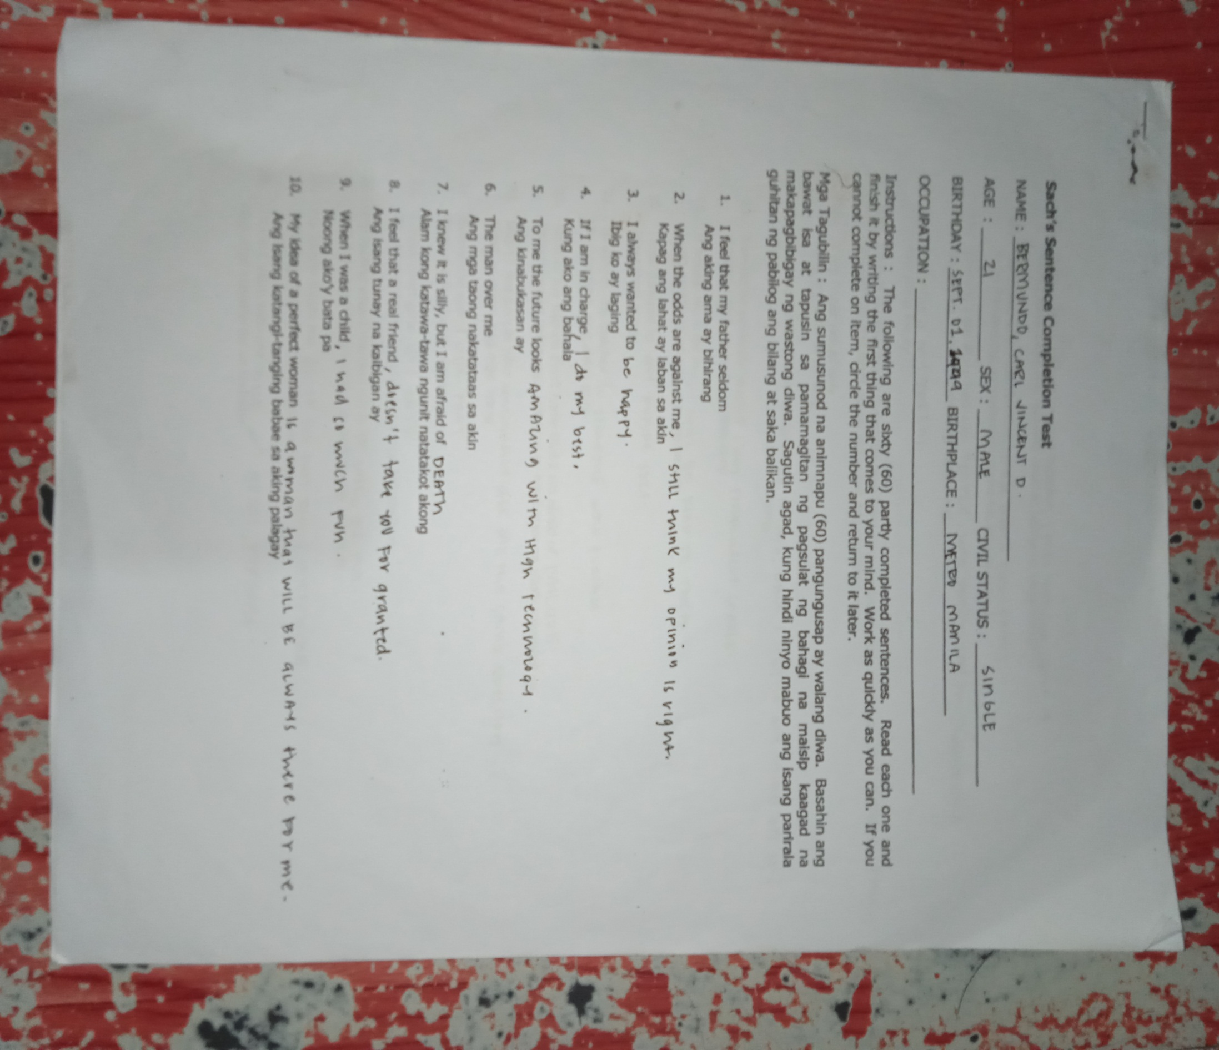(SSCT)**







**House-Tree-Person Test (HTP)**

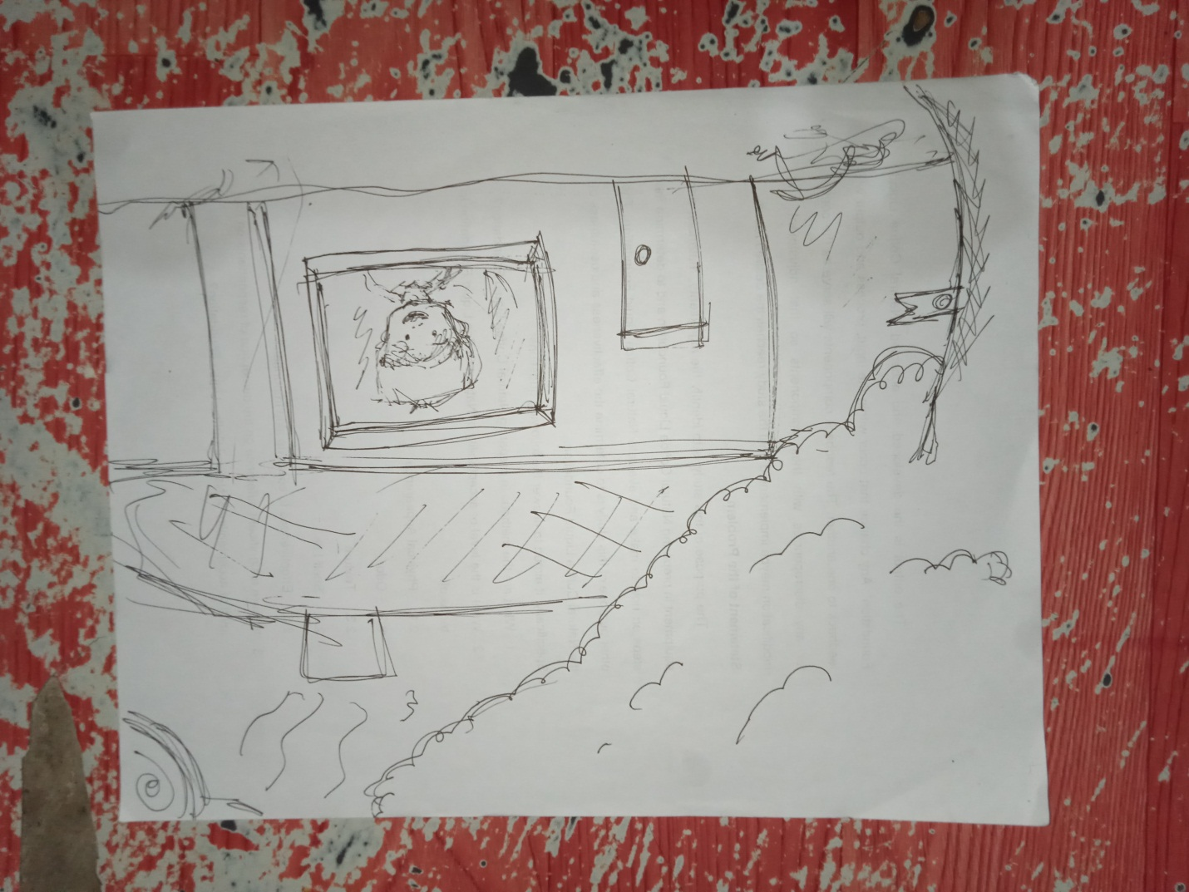

**Draw a Person Test**

**Female**

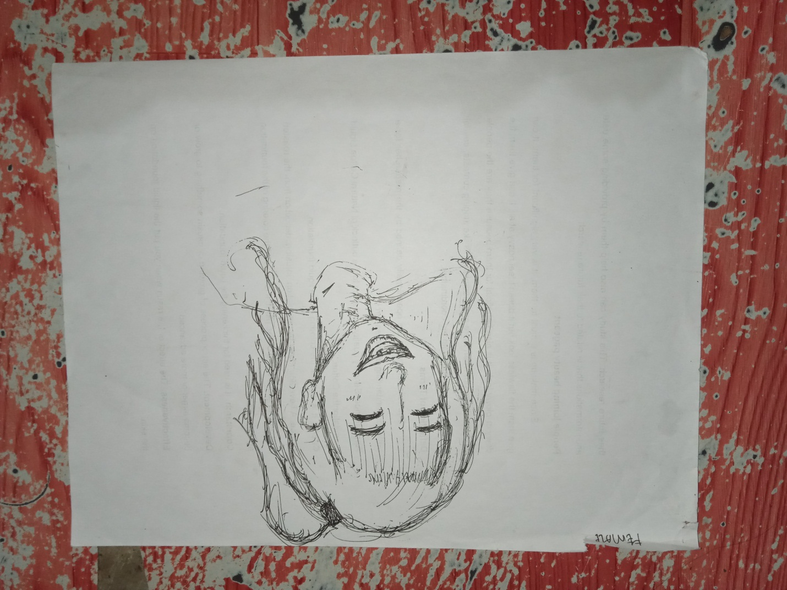

**Male**

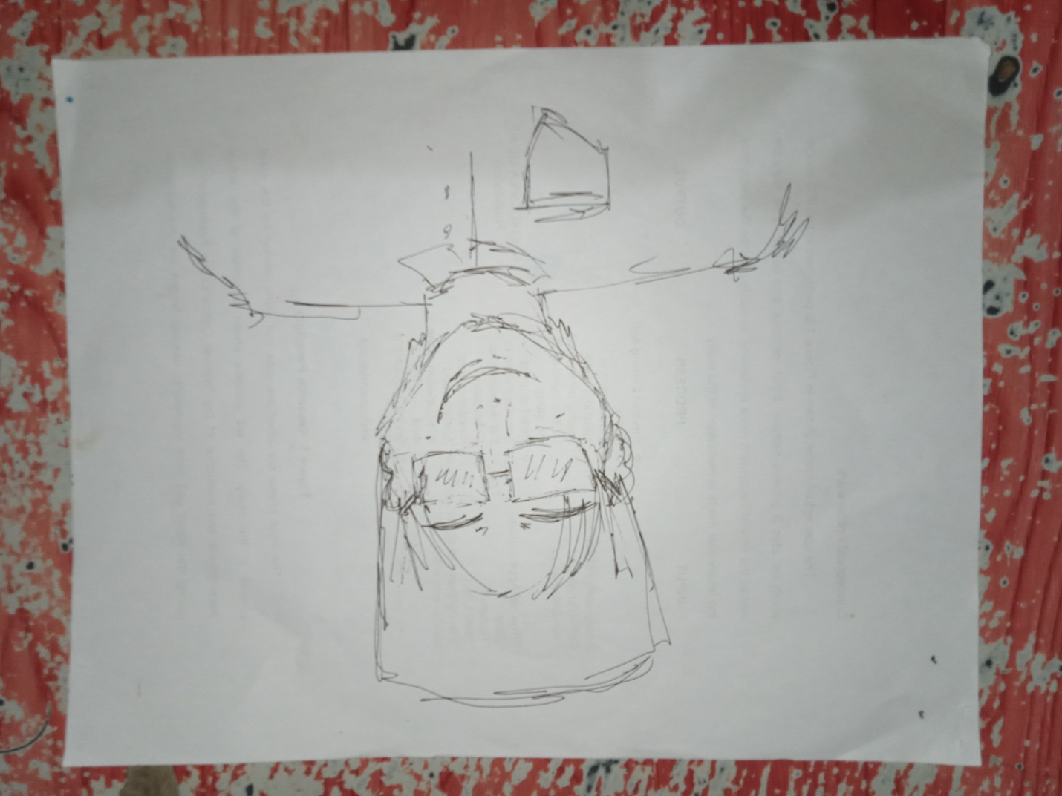

**Bender-Gestalt Visual Motor Test**

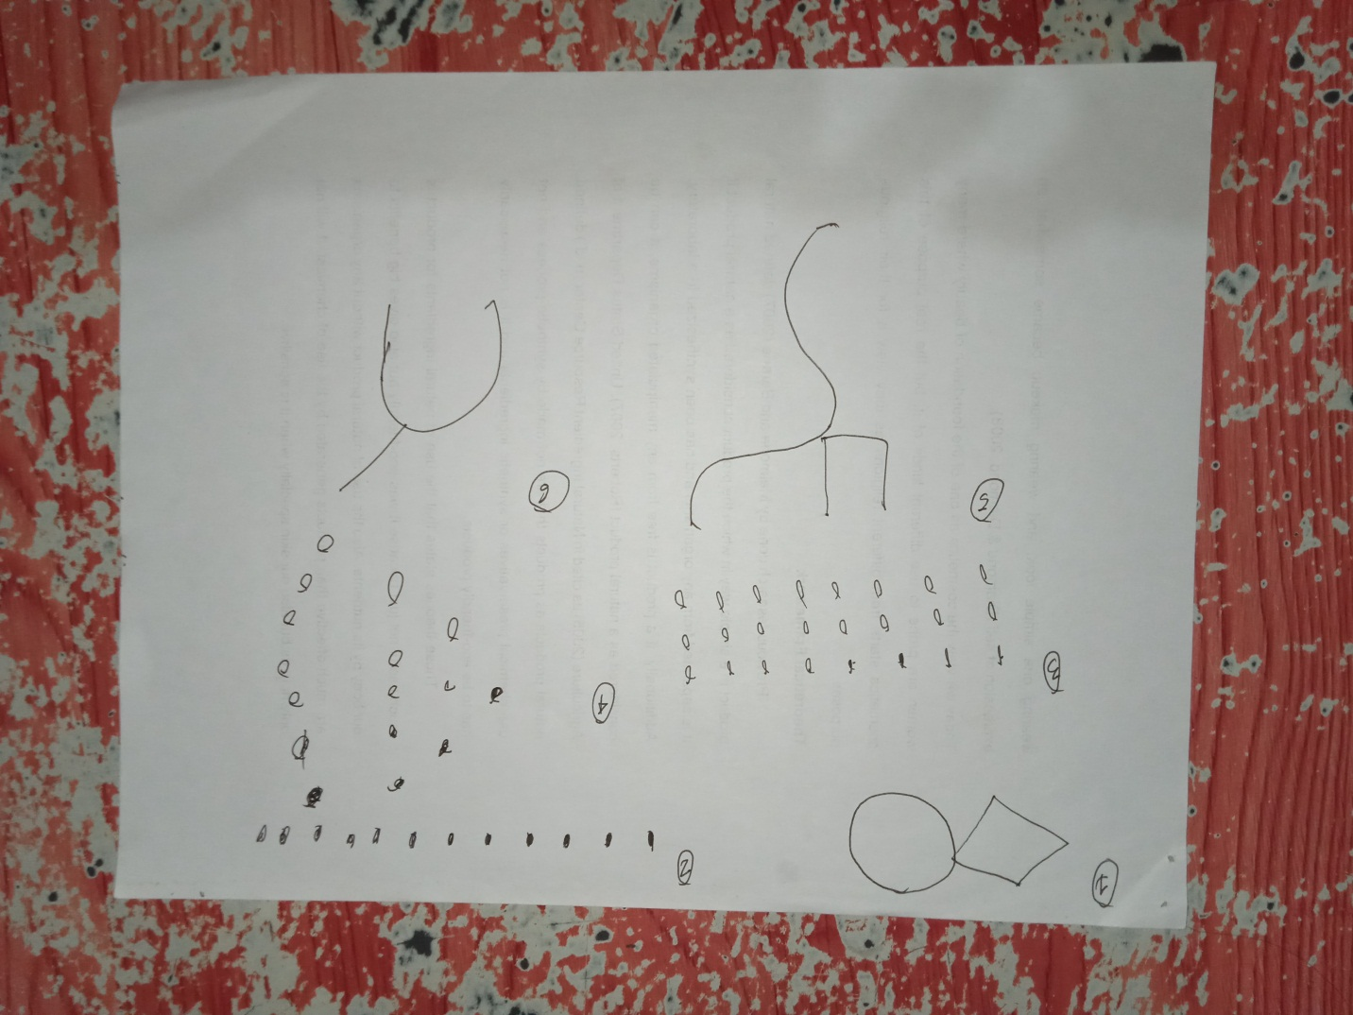

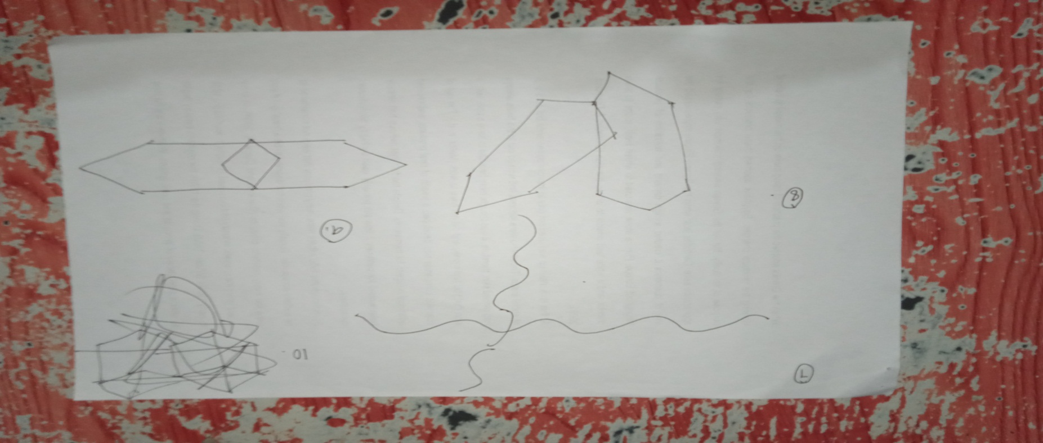

**Emotions Profile Index (EPI)**

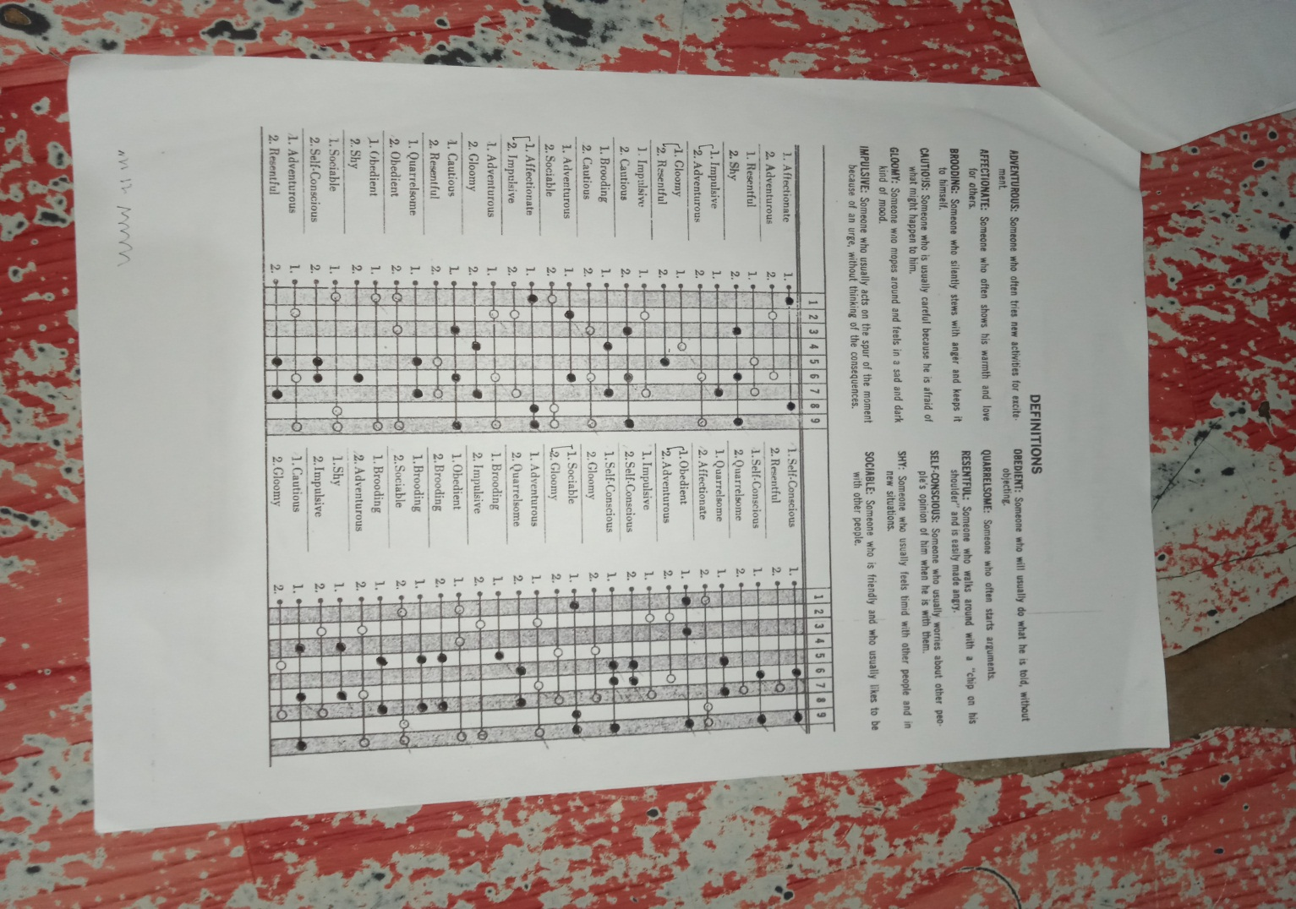

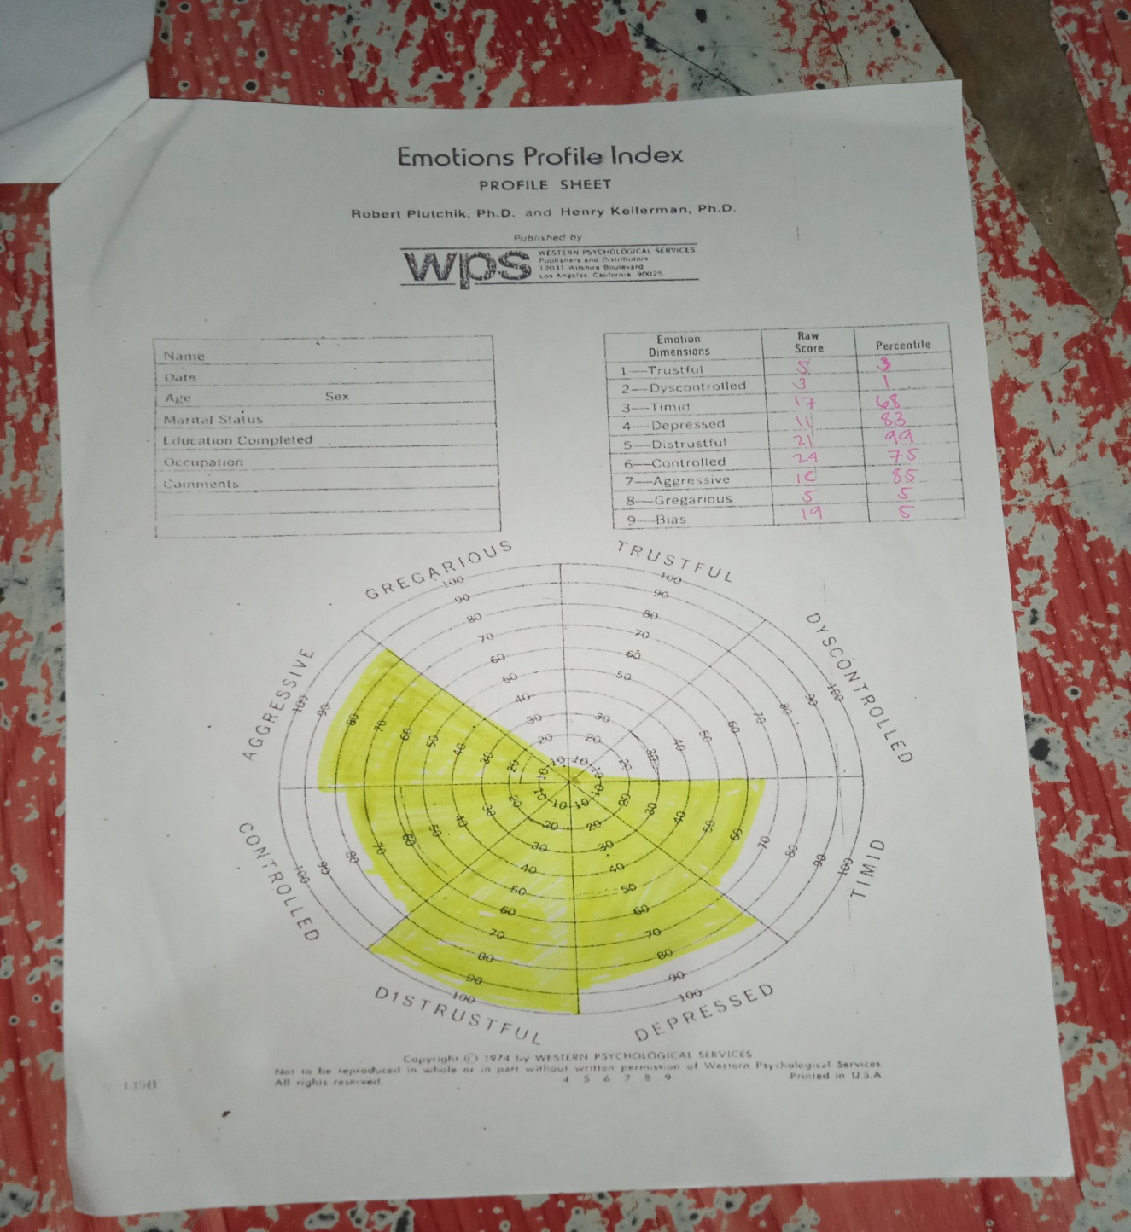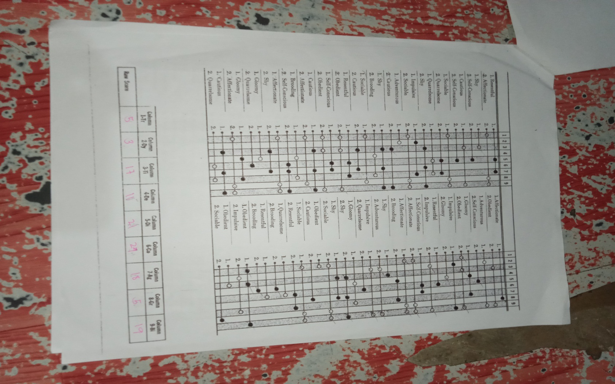

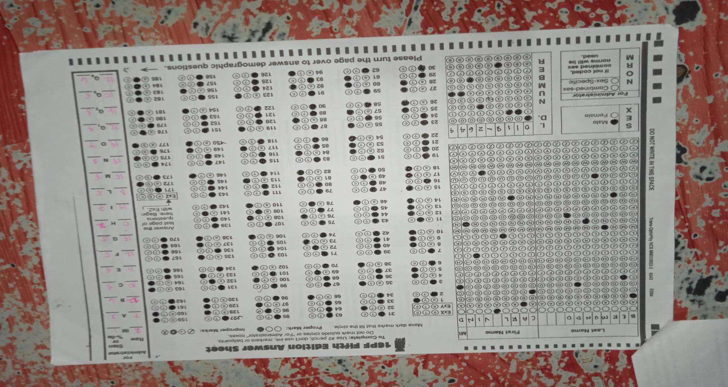**16PF**

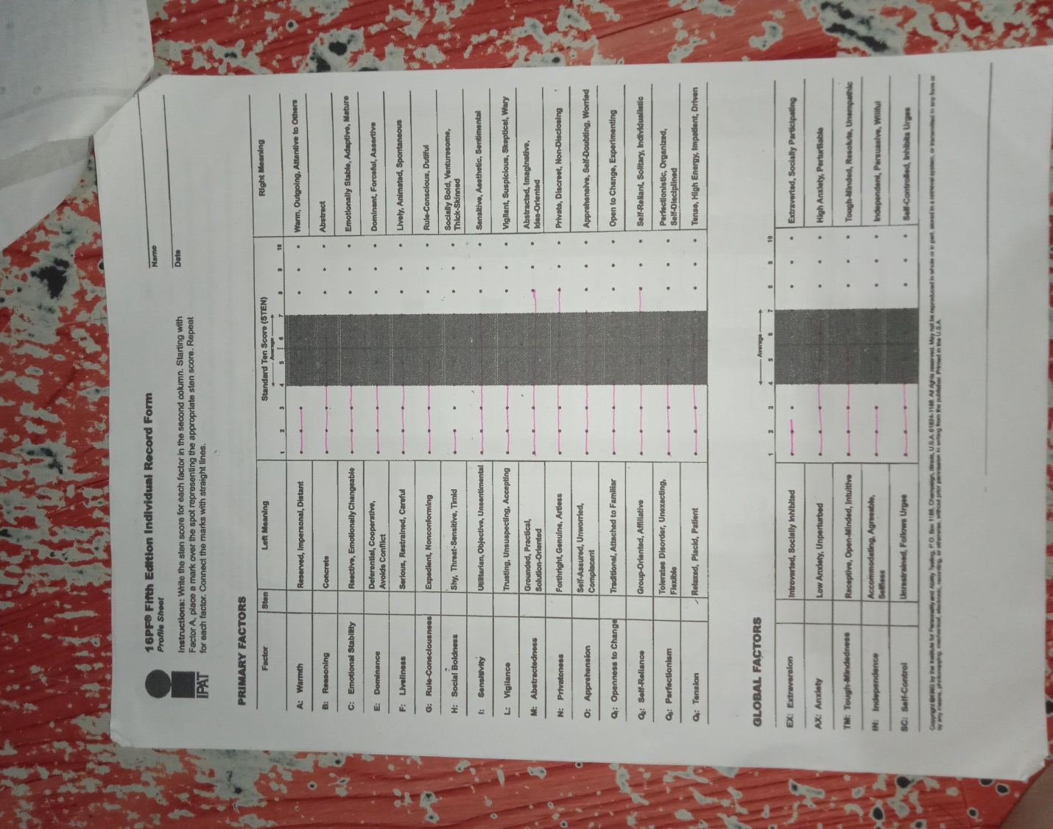

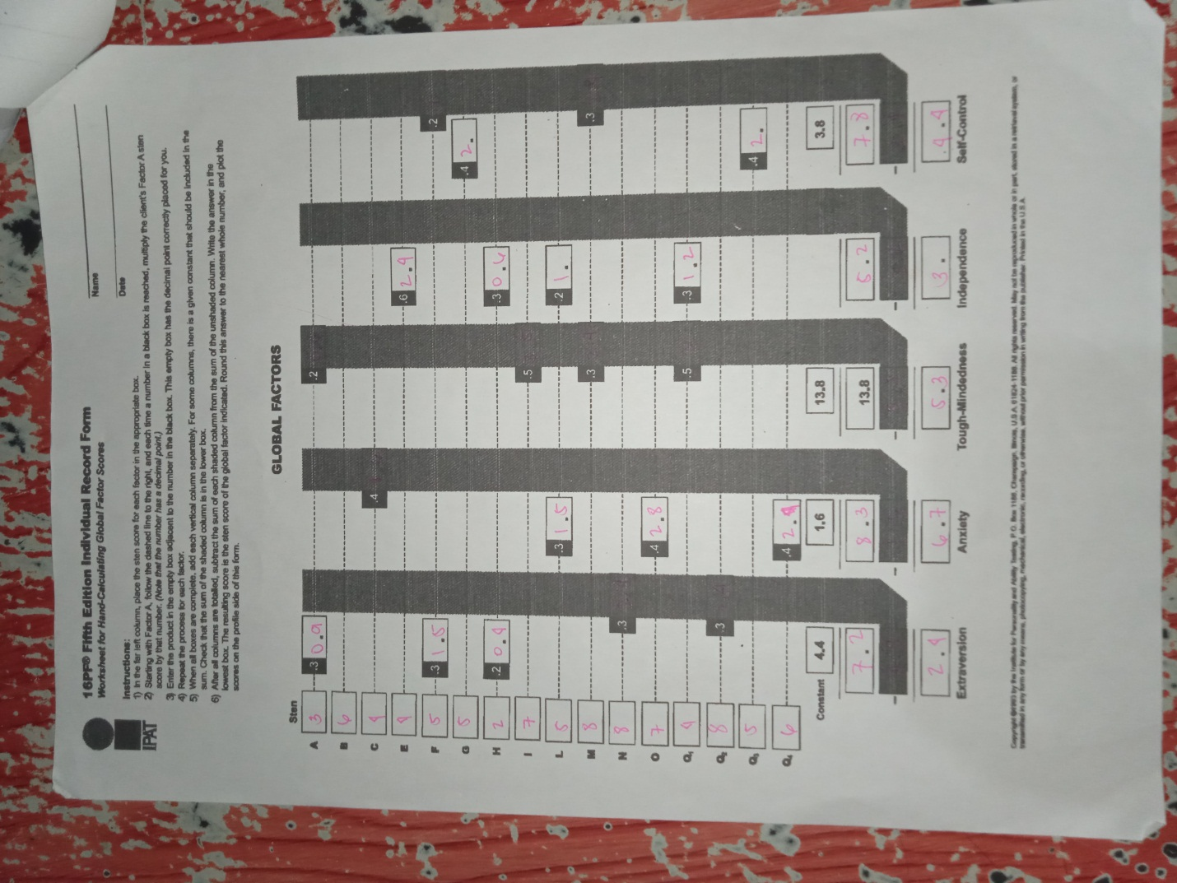

**Purdue Non-Language Test (PNLT)**

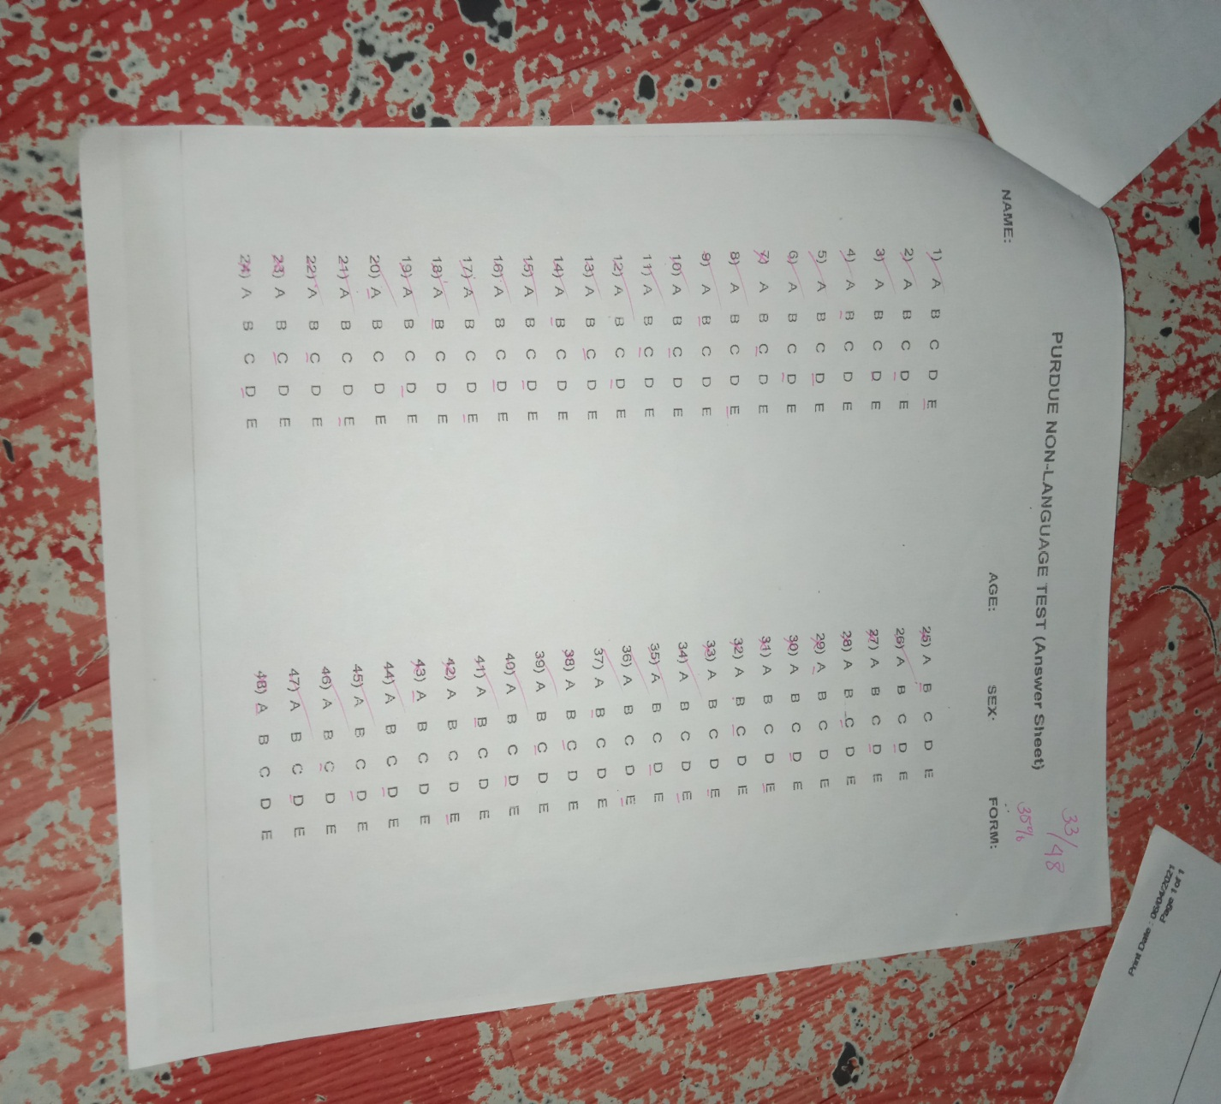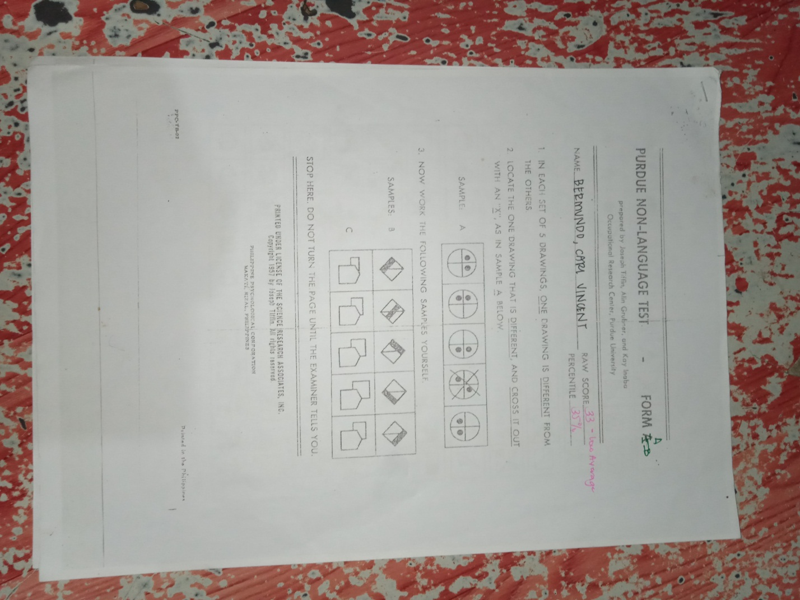

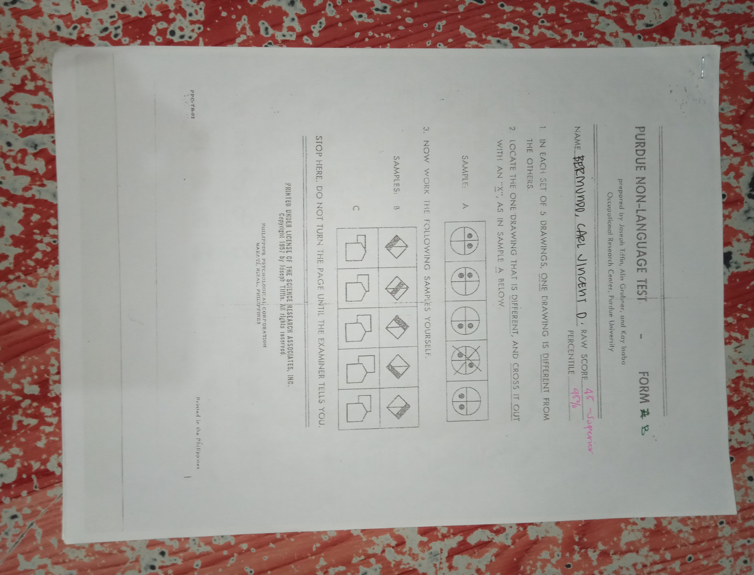

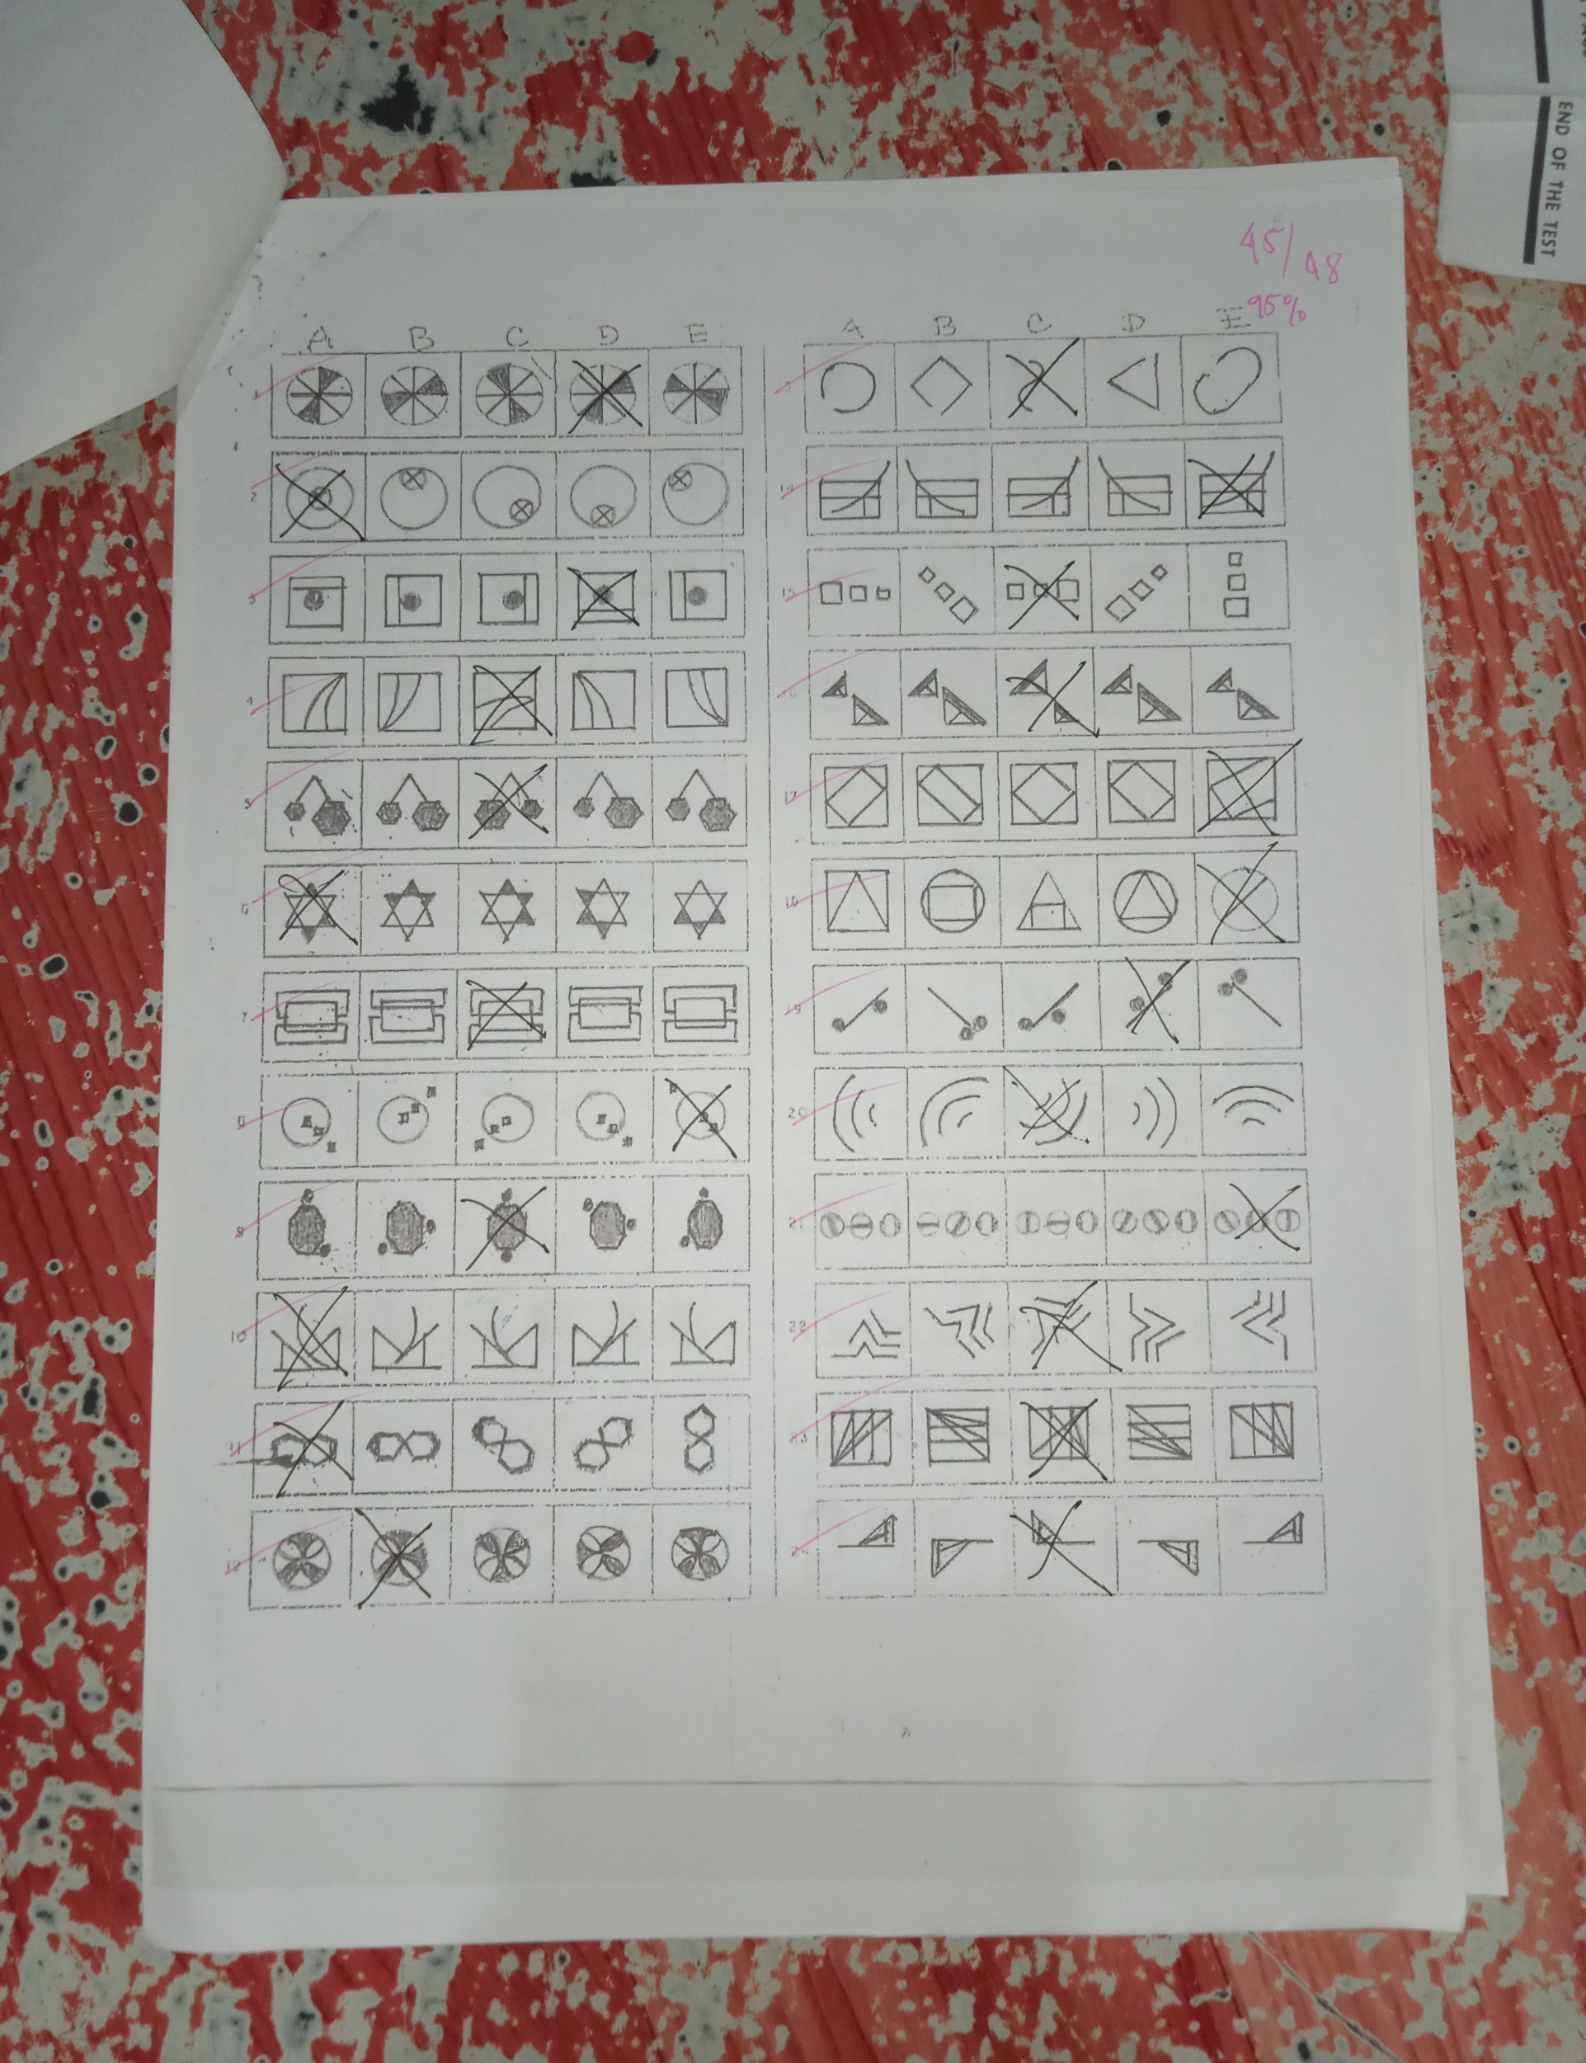

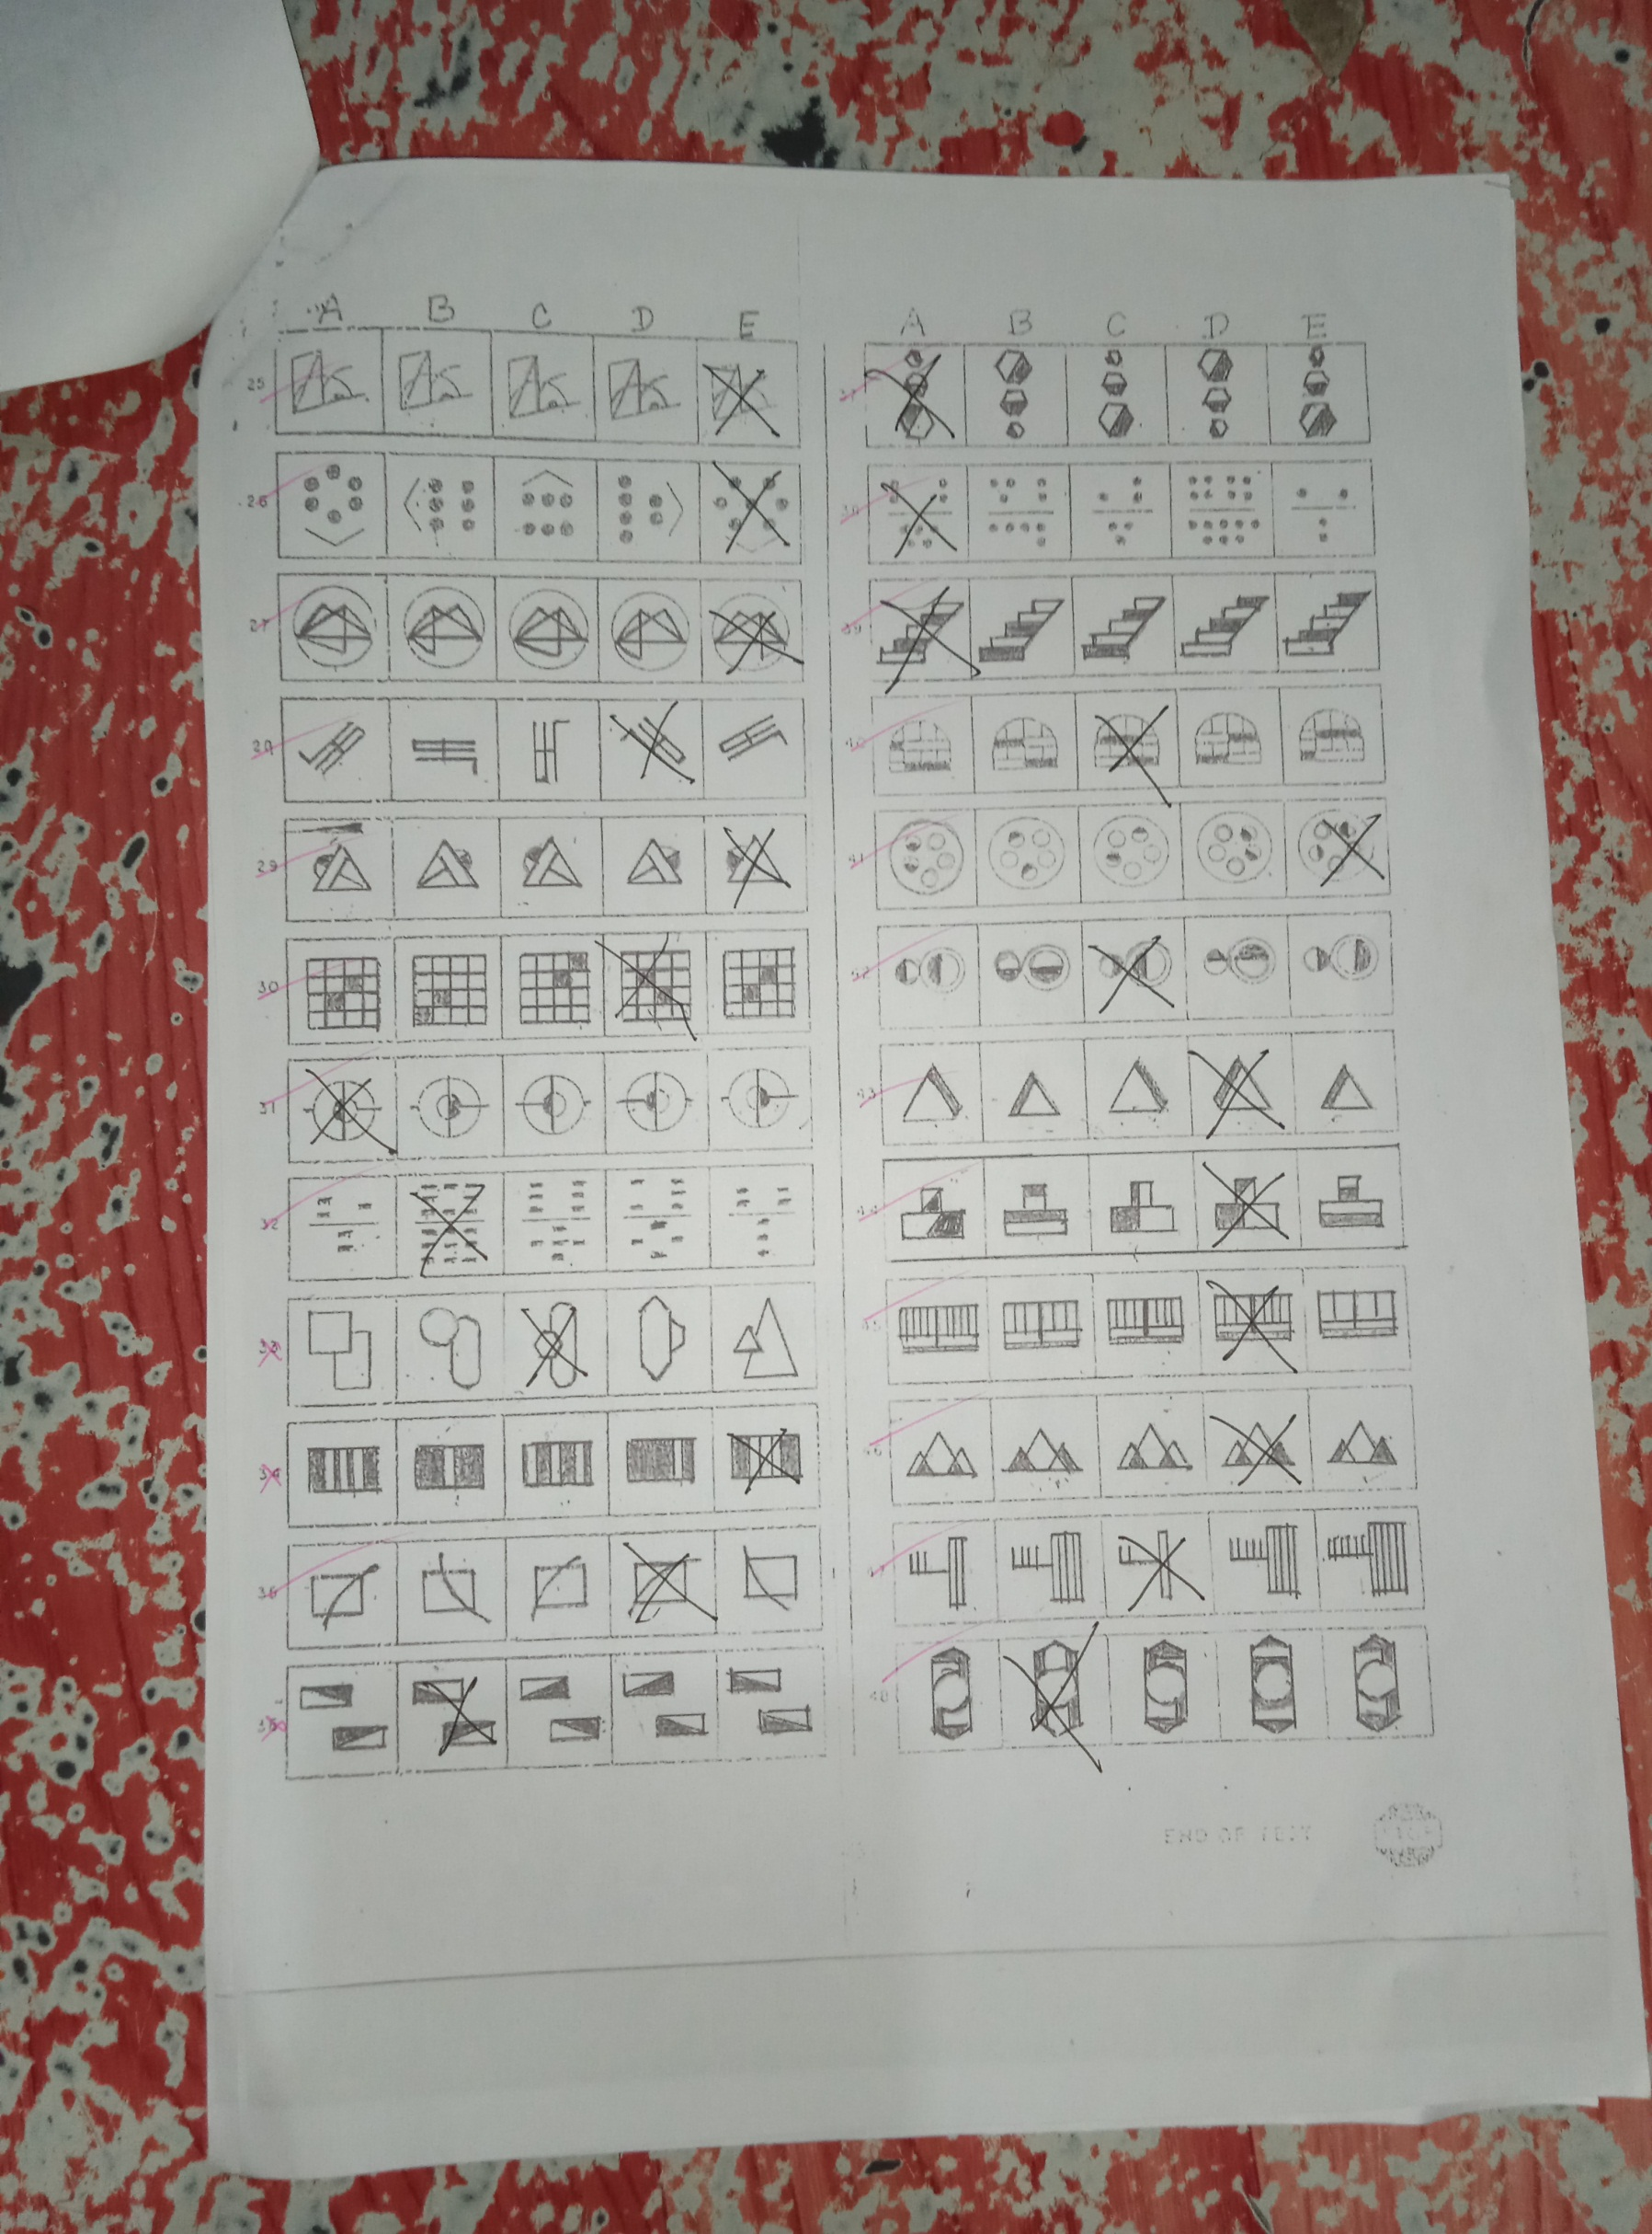

**SRA Verbal Test**

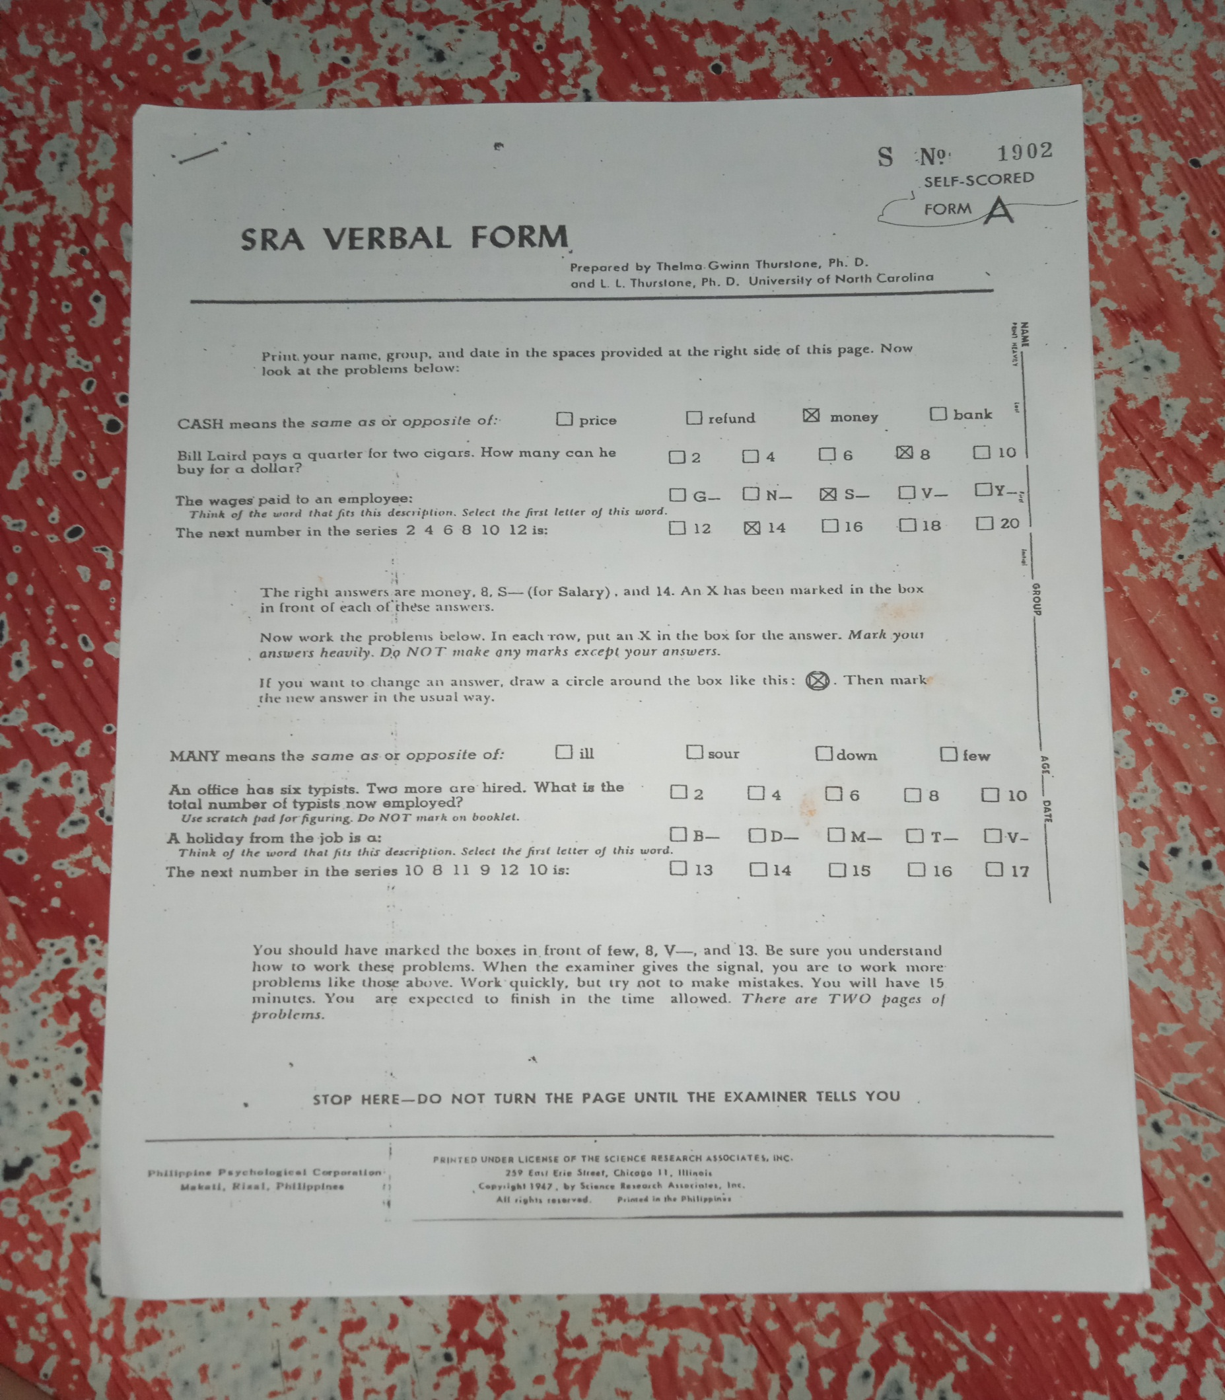

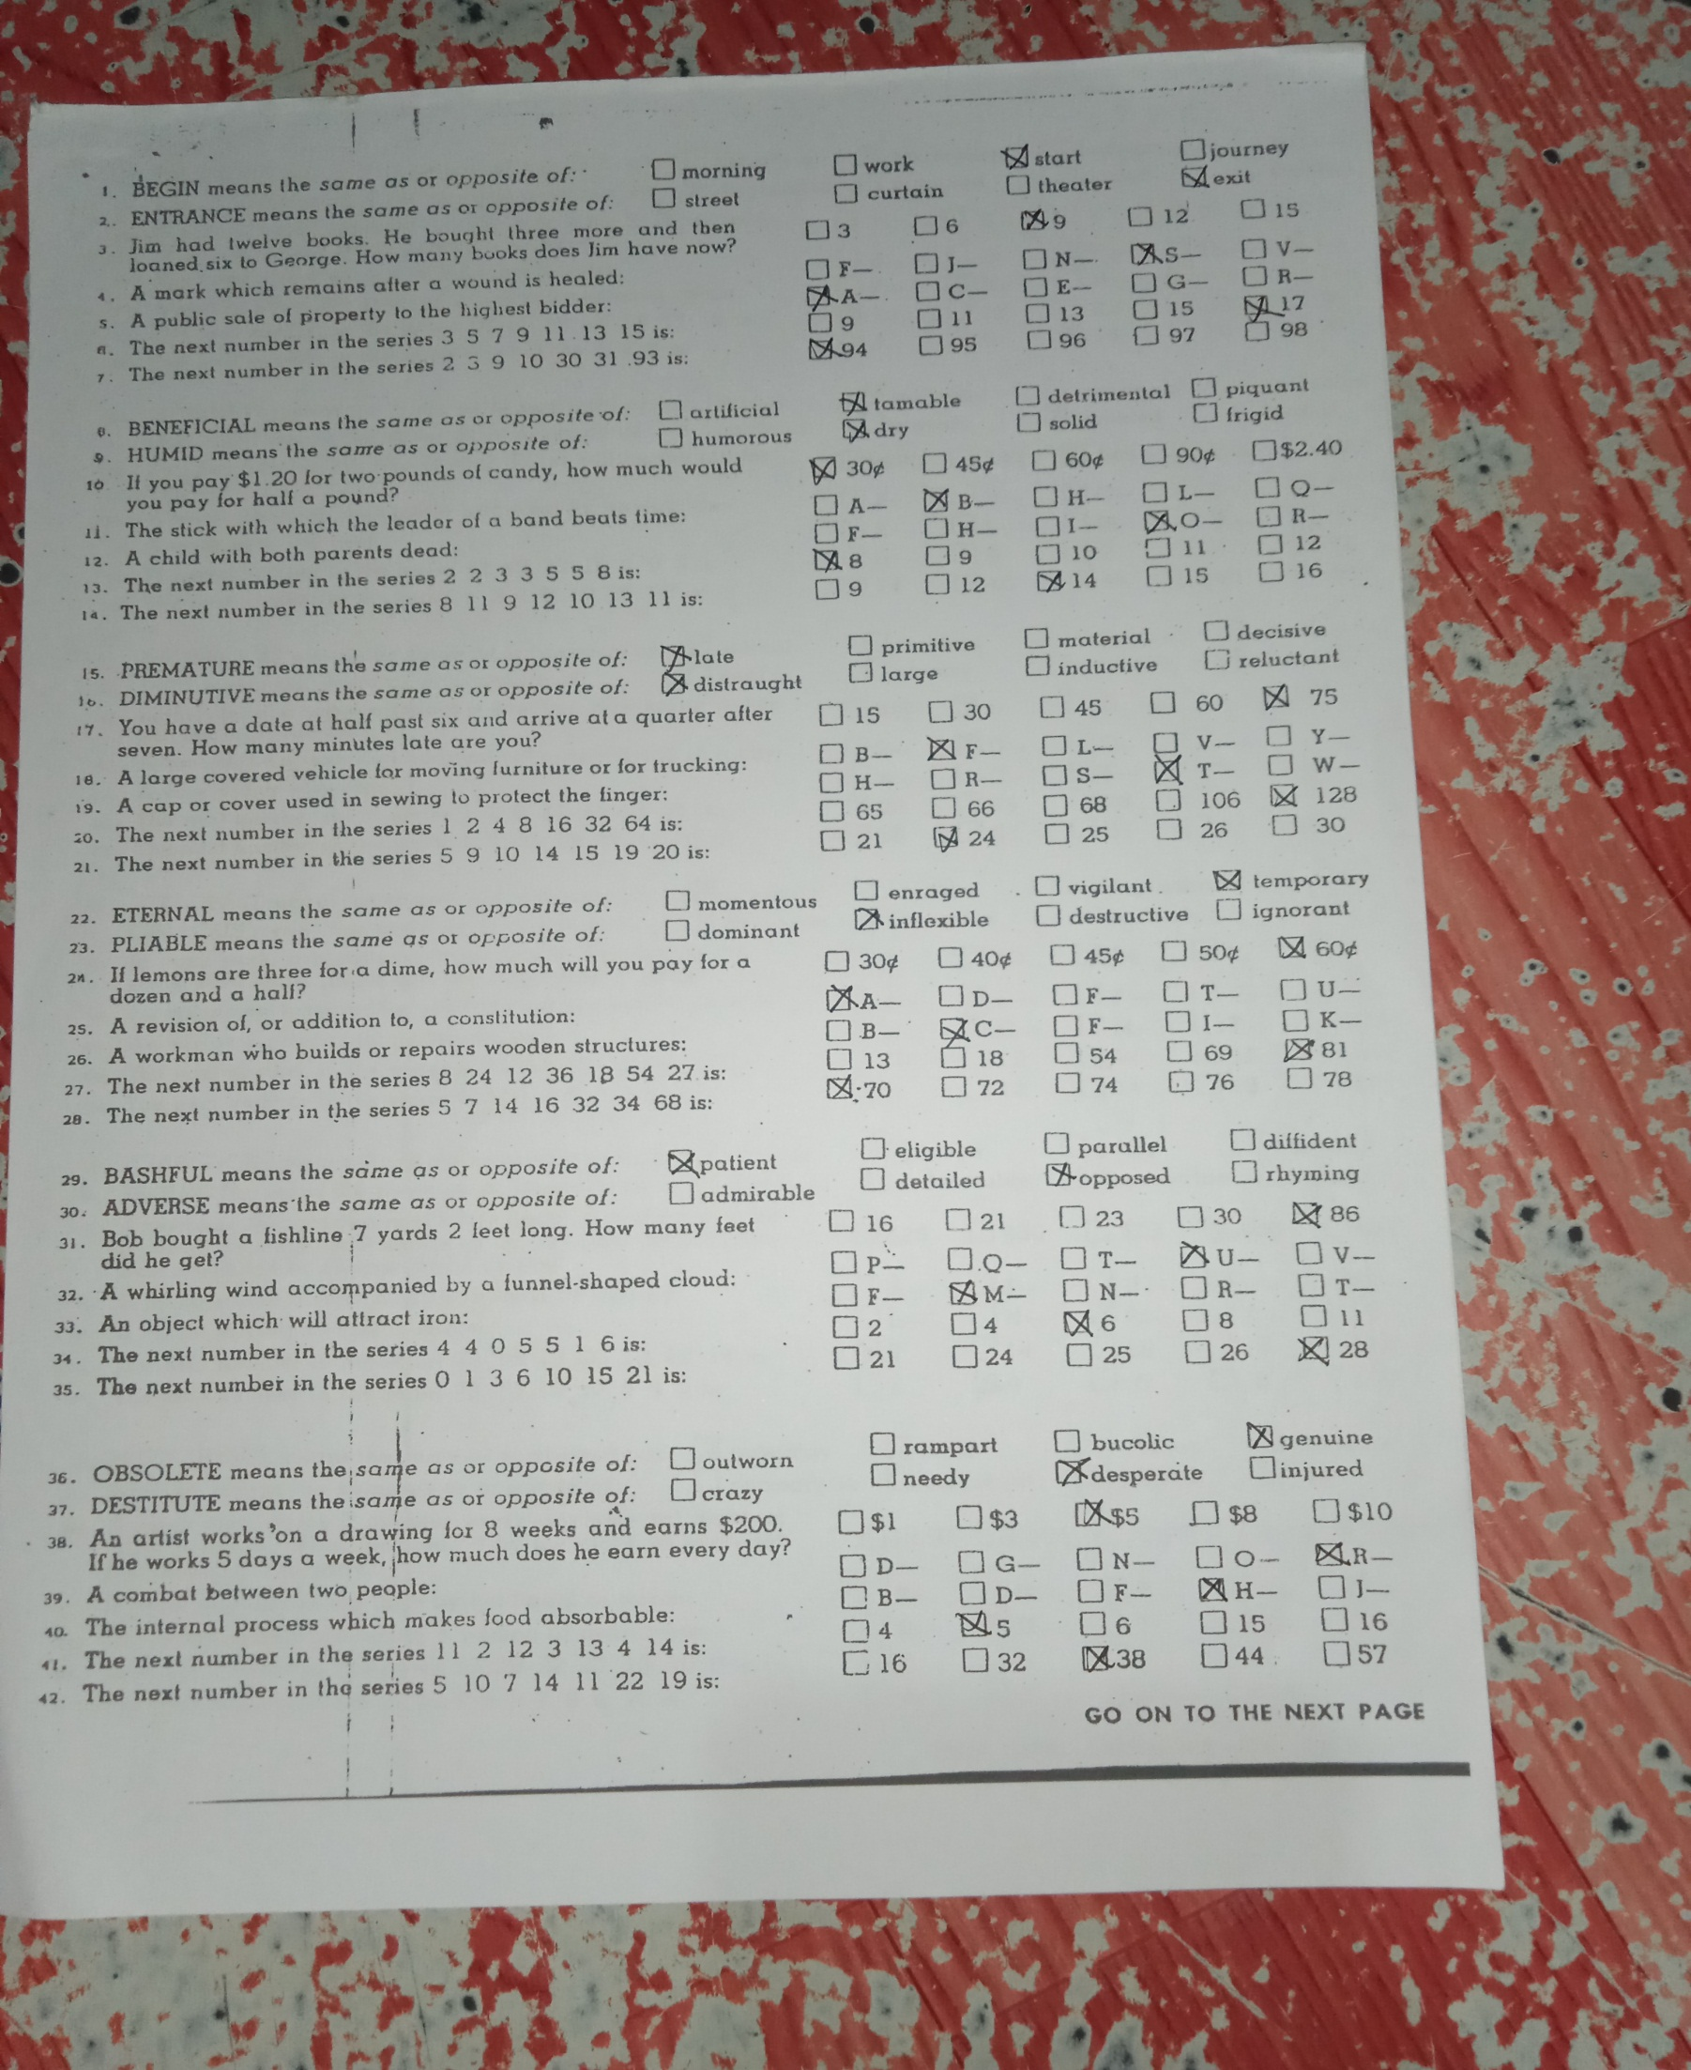

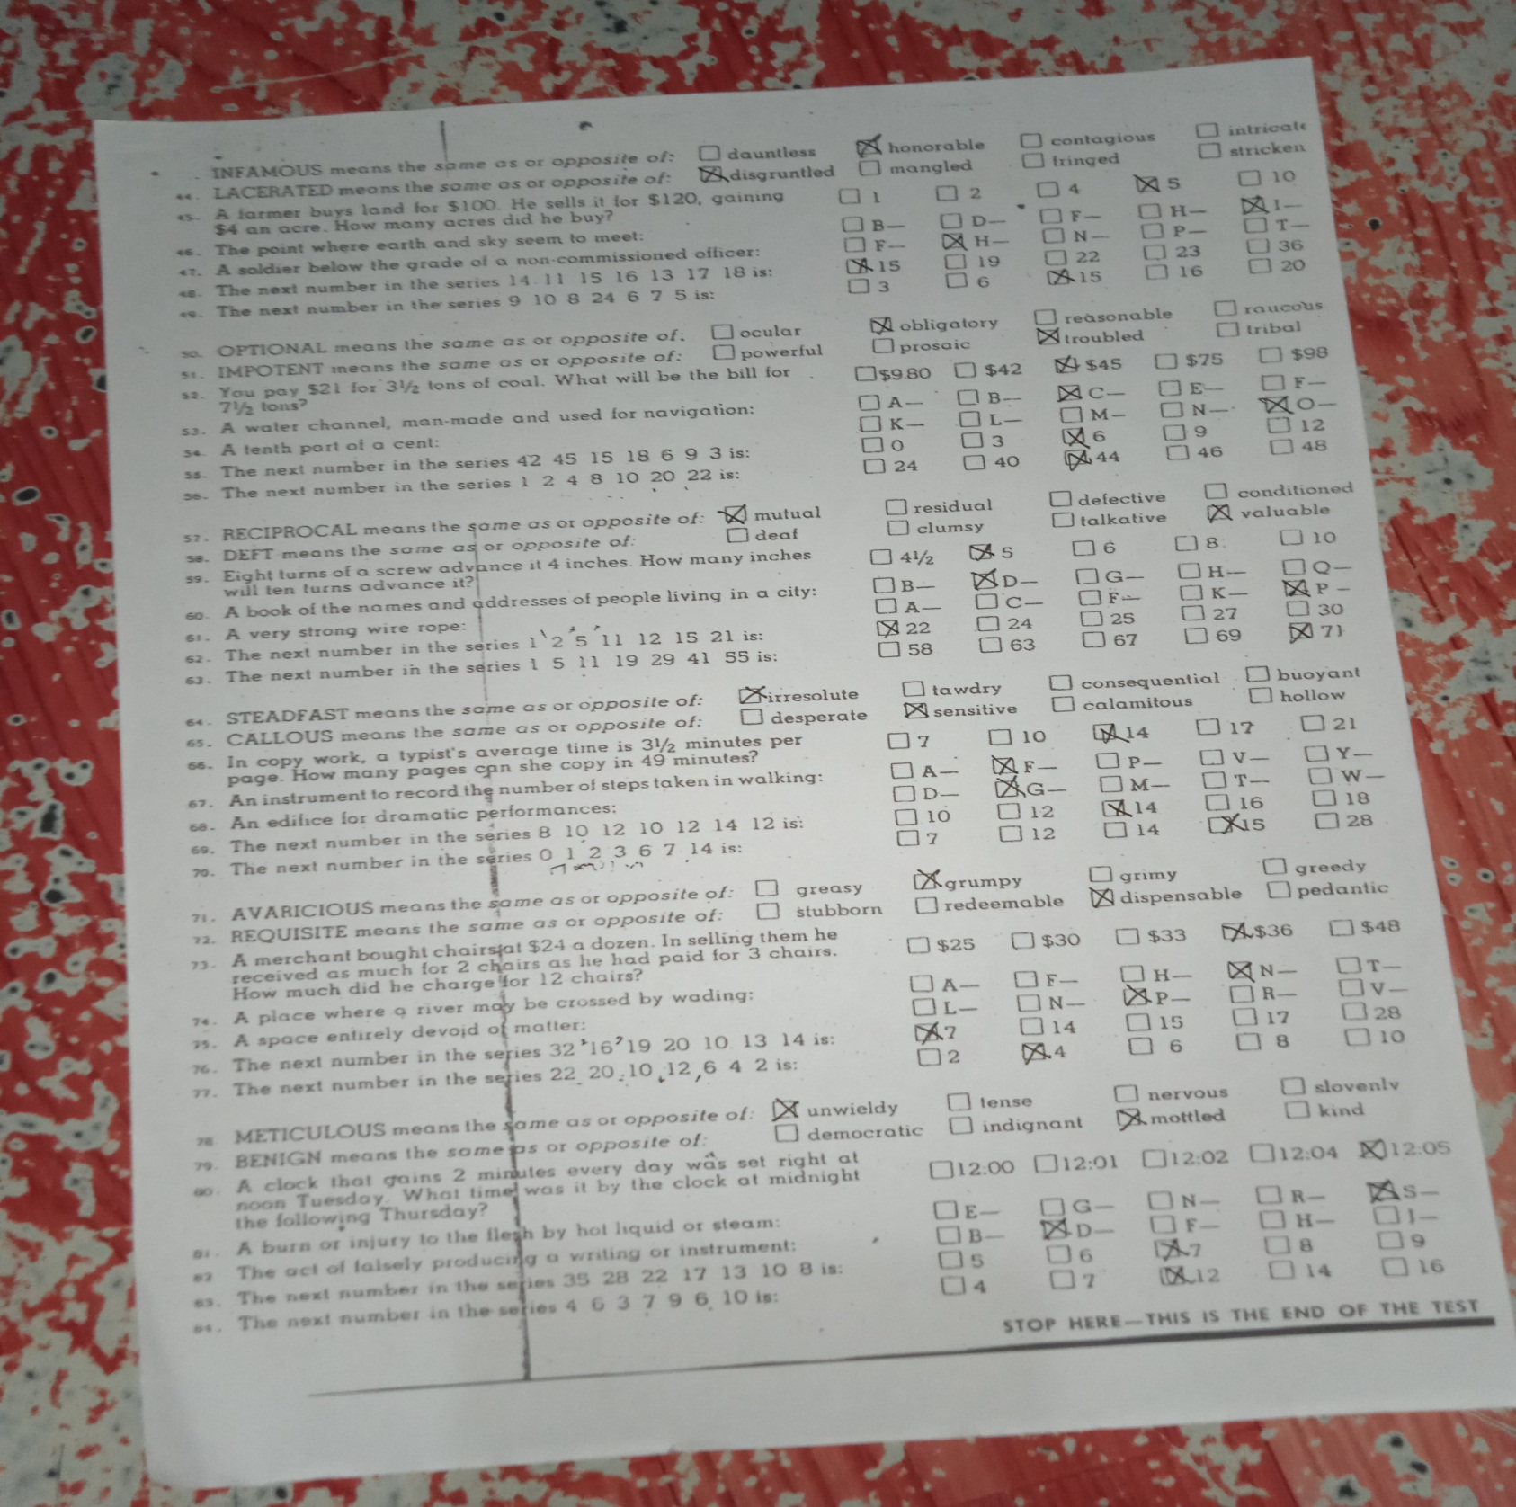



Bergonia, Joanah Marie M.

Name & Signature

Psychodiagnostician